Crime Record Management System



Presented By group ‘E’

Srikanth Reddy Narra (Z1947038)

Darshan Kumar Saravanan (Z1947418)

Ravi Teja Medikonda (Z1947118)

Bheemeswara Gopi Reddy Battula (Z1947307)

**Project Deliverable 1**

**Crime Record Management System**

The Government of Bihar wanted to improve the database system to keep track of all crimes that have occurred in the State. The police department can make use of the system to refer the cases in the past and assign police officers to a certain location in the future based on the crime statistics in that location. This process should store all the information regarding crimes, starting from the First information received on an incident to the verdict given for that particular Incident.

Bihar Police deploys several police officers to handle the crimes reported in various cities, where each city has a few police officers who will be taking in-charge of all the crimes that occur in the city. The police officers in the police station receive the information on the crimes from the informant of the incidents. The police officer needs to store the informant's details and the police officer needs to write a crime report on the received information. The police officer from a police station can handle numerous crimes on his duty.

The investigation of the crime starts once the crime is recorded. In the process of investigation, the police officers start to identify the victim and the suspect involved in the crime. The police officer seeks information from the victim on the occurred crime incident to differentiate the type of crime and keeps a note on the sections that can be enforced for a particular crime type. In the further stage, the police officer will identify the suspects involved in the crime, however, the suspect may be involved in other crimes as well. The details of the identified suspects need to be stored separately and their motives in each crime will be recorded during the investigation, which will be updated periodically. Similarly, the details of each victim of crime are noted separately and their status is updated accordingly during the process of investigation. The crimes with unidentified victims and suspects will be pending until further details on them are known.

Once the criminal record is finalized with the victims and the suspects involved in it, the crime will be taken for hearing in the court, the verdict for the crime will be given based on the type of crime, the motive of the suspect who is involved in it, and the sections that can be enforced on each suspect involved in the crime. If the suspect is found guilty, the punishment will be given based on the offenses that he took part in, by enforcing all the sections under that crime.

**Project Deliverable 2**

**Entity-Relationship Diagram**

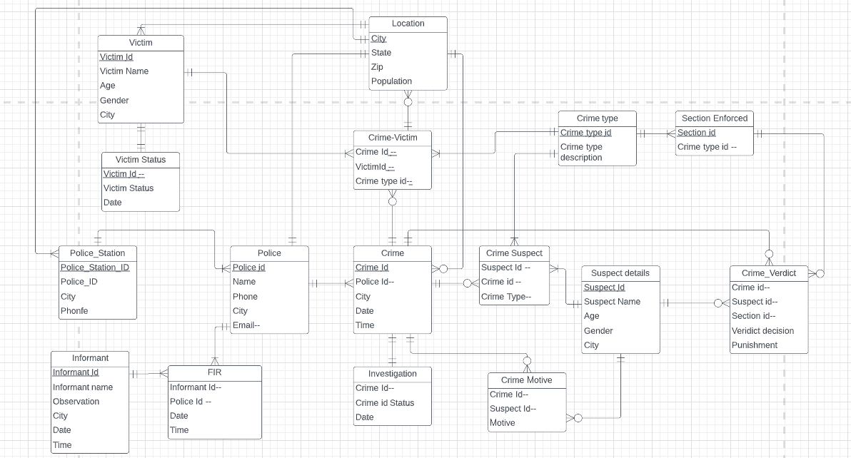

**Assumptions:**

* A city can have Zero- or- Many crimes reported, however a crime_id and city can have one or Many Police_Station_id.
* Each Police station can have One or Many Police working in it.
* There can be one or more Informants that can file an FIR, but an FIR can be filed by One-One Informant.
* A police officer can have One-or –many FIR’s under his belt, however, an FIR can be assigned to one and only police officer.
* A police officer can handle one or Many crimes, and he’s the point of contact of the police station.
* A victim can be affected by one or many crimes, and vice versa.
* So, the Many-Many relationship for crimes and victims effected can be avoided by using the “bridging entity” Crime_Victim.
* The Crime_victim table can uniquely Identify the Crime_Type table as it has composite primary keys Victim ID, Crime ID , Crime_Type_ID , all three involved. However, a crime_type can have one or many Victims affected by it.
* A Crime can involve one or many suspects, and Vice Versa. Crime_Suspect table acts as a bridging entity between crime table and Suspect details table.
* The Crime_Suspect table can uniquely Identify the Crime_Type table as it has composite primary keys Suspect ID, Crime ID , Crime_Type_ID , all three involved. However, a crime_type can have one or many Suspects involved by it.
* The verdict is given by the jury based on a Particular Suspect, crime Involved in and the Sections that can be enforced under a crime committed.
* The suspects Motive also plays a Vital role for the verdict decision.

**Data Base Diagram**



List of Tables/Entities:

1. Informant_Details:

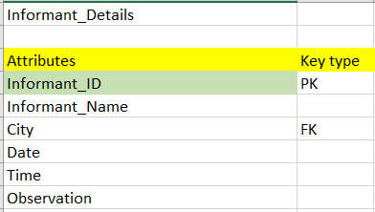

1. First_Informatio_Report:

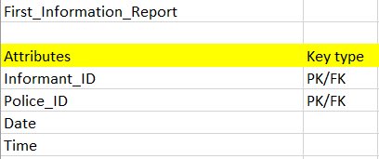

1. Police_Info:

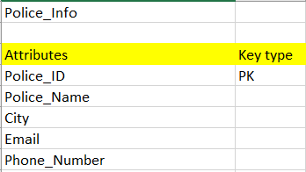

1. Police_Station:

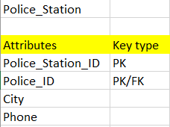

1. Crime_Details:

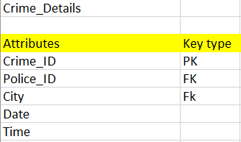

1. Location:

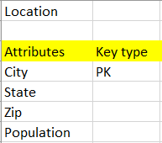

1. Investigation Status:

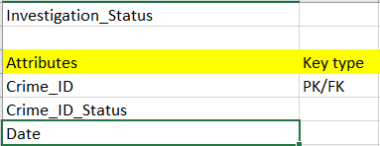

1. Crime_Type:

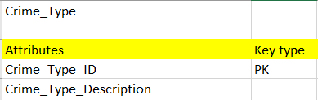

1. Section_Enforced:

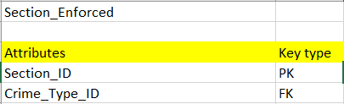

1. Crime_Victim:

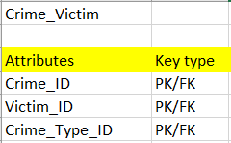

1. Victim_Details:

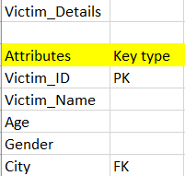

1. Victim_Status:

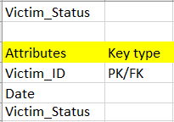

1. Crime_Suspect:

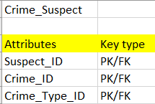

1. Suspect_Details:

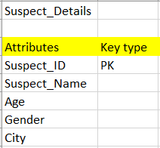

1. Crime_Motive:

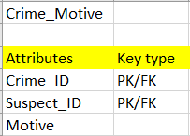

1. Crime_Verdict:

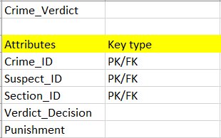

**Queries**

1. List the number of crimes reported in the Cities of Patna,Muzaffarpur and Gaya?

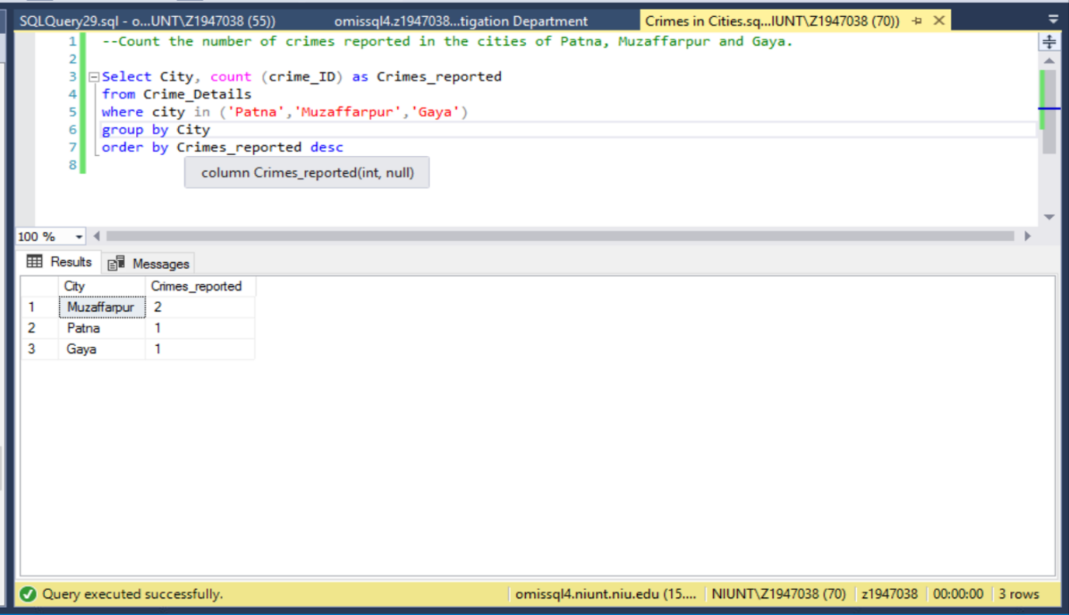

1. Find the Suspect_Name and Suspect_ID who Victimized Karthick, Seethama, and Nitheesh? Also, mention the Crime_Type and Crime_Description that was commited?

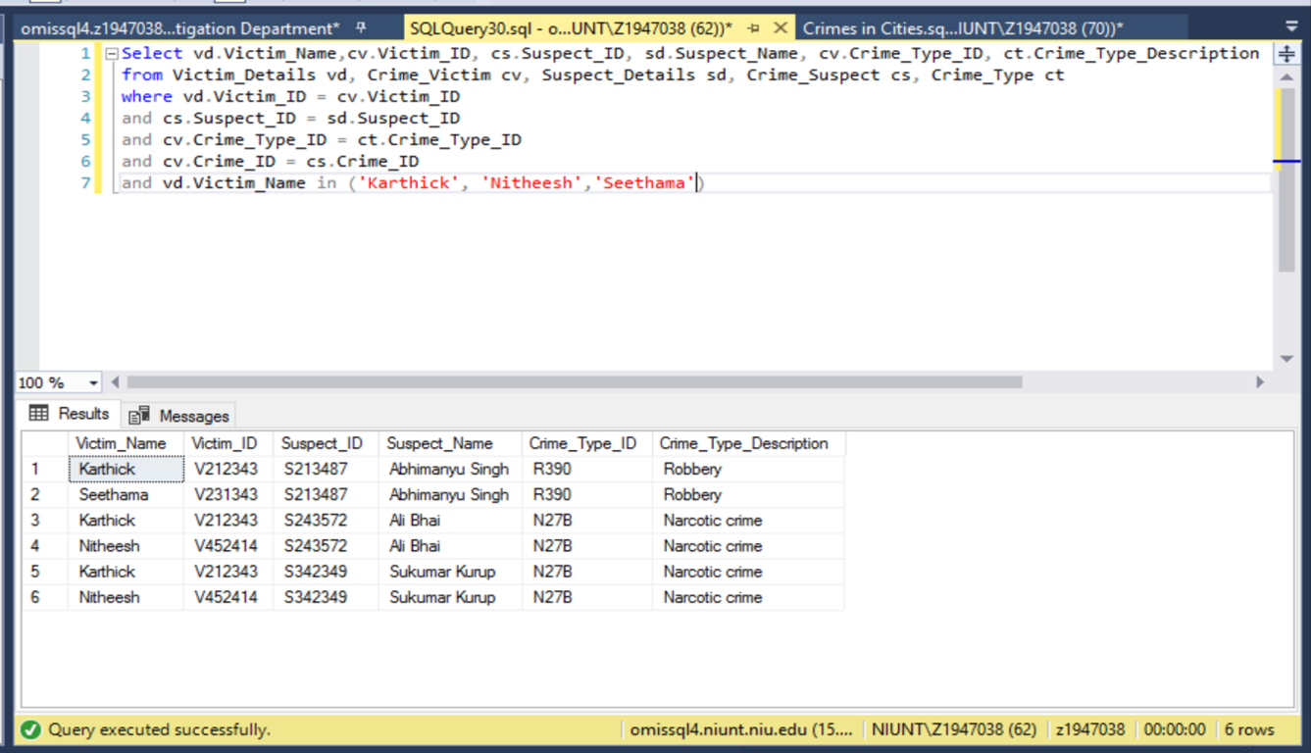

1. Find the Police Officer who handled the case of suspects Ali Bhai and Sukumar Kurup?

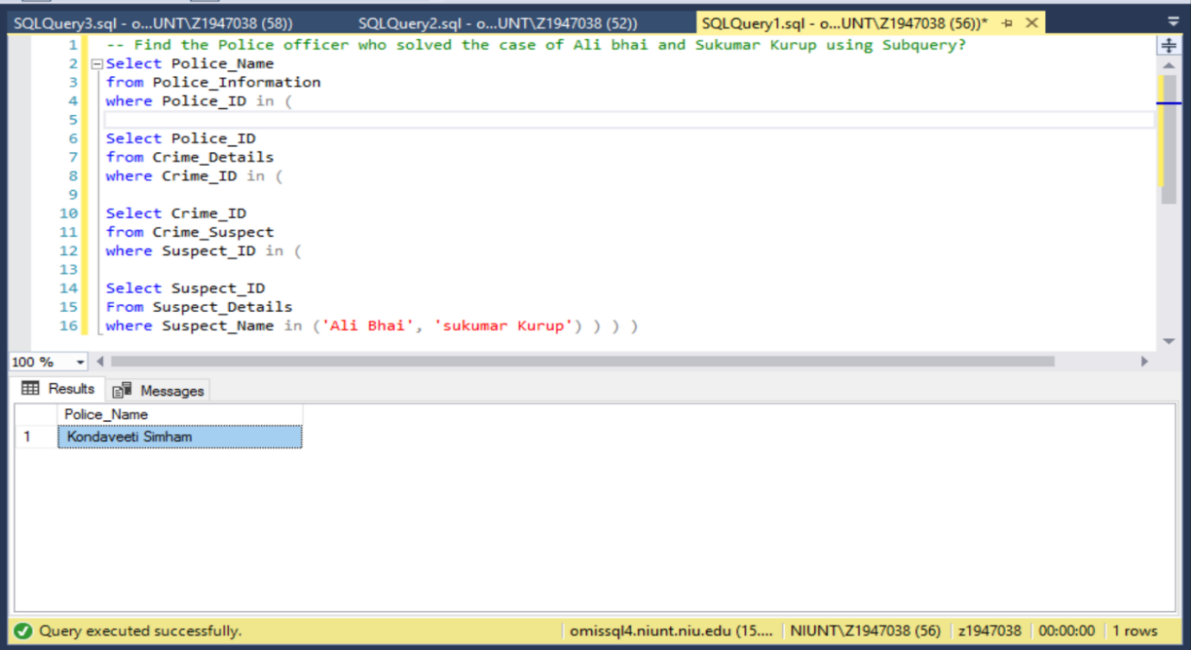

1. Find the Suspects and their Motive Involved in the Crime ID C102345?

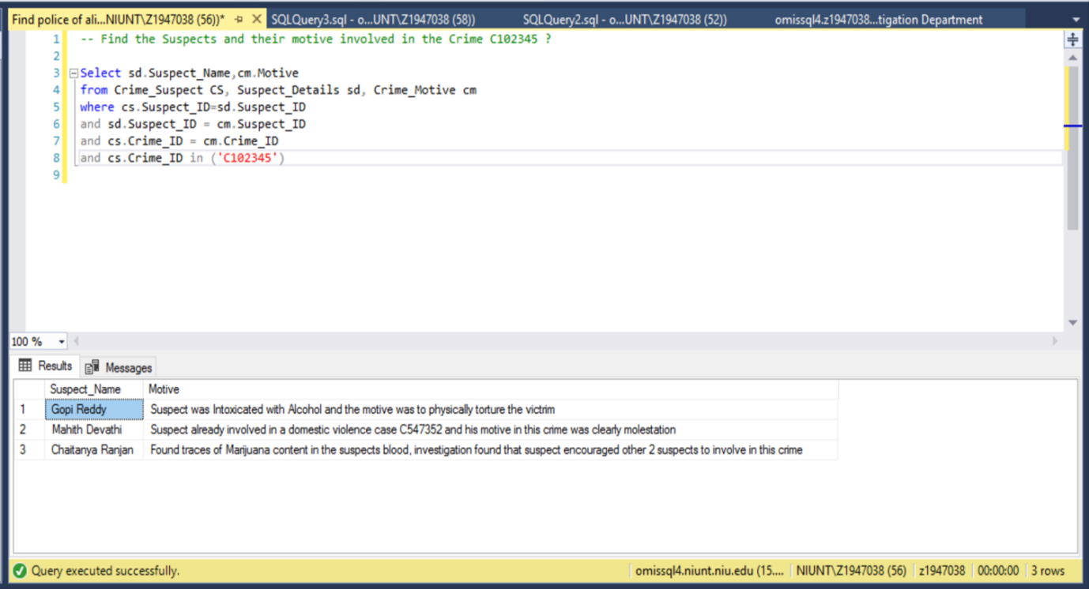

1. List all the Crimes recorded along with the victims and Suspects Involved in a Crime?

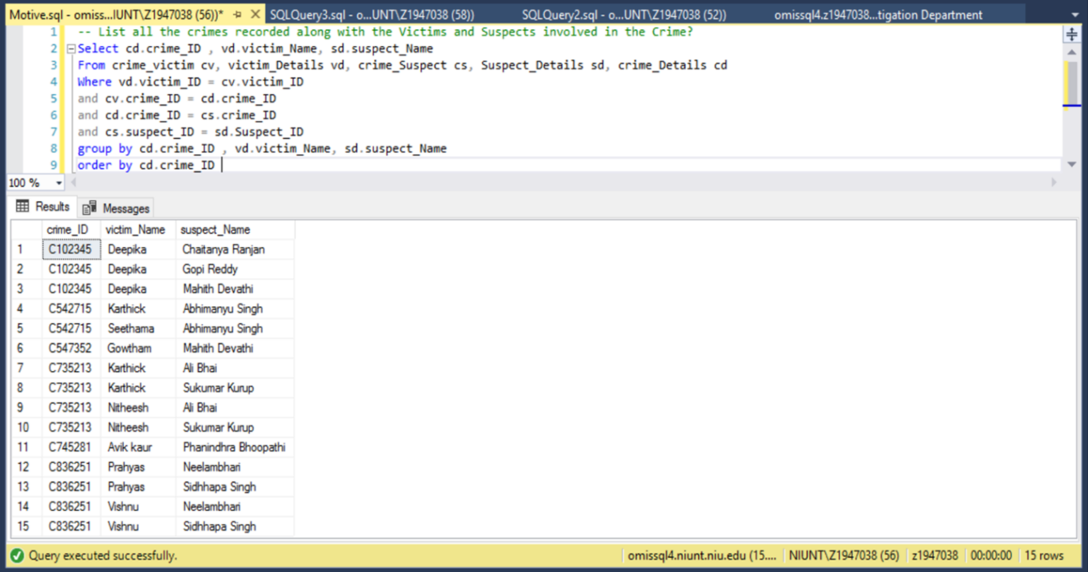

1. Find the Crime_ID, Date of Crime Comitted, and Crime_Type_Description from the Crime, Suspect “Mahith Devathi” was Involved in ?

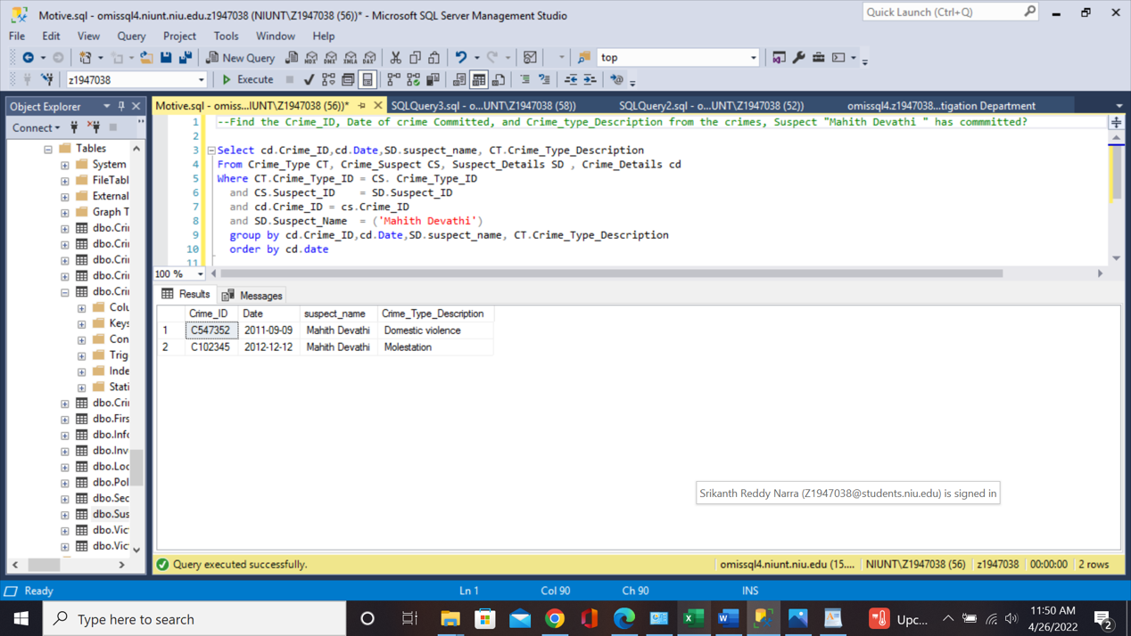

1. Display the Verdict, Punishment , and the sections Involved in the Crime C102345, along with the Victims and Suspects names involved in the crime?

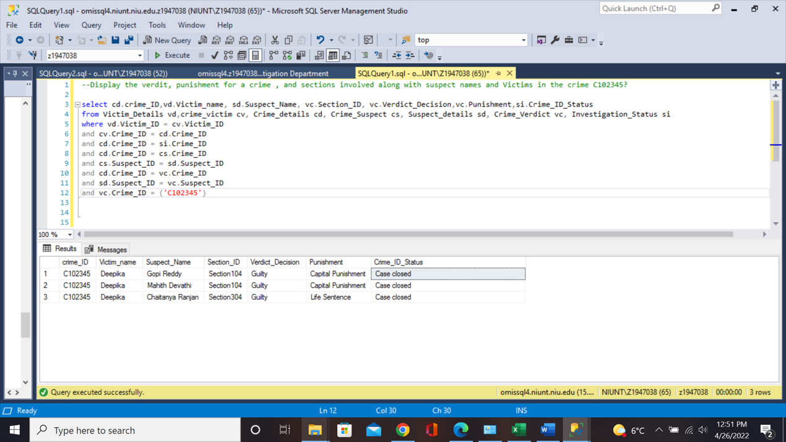

1. Display the names of all the suspects whose age is greater than 25?

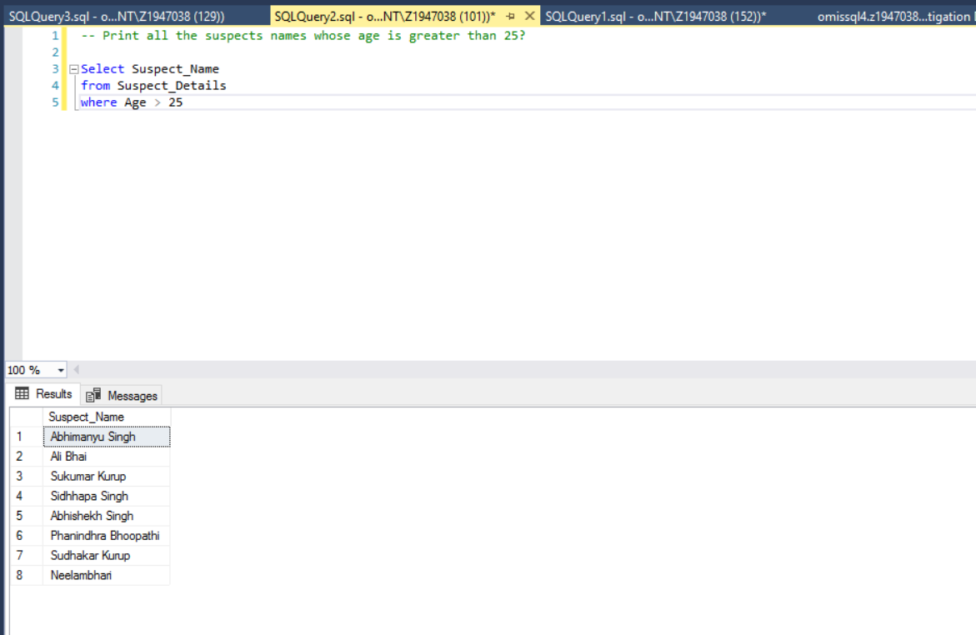

1. What are all the Sections Involved in a crime on Molestation?

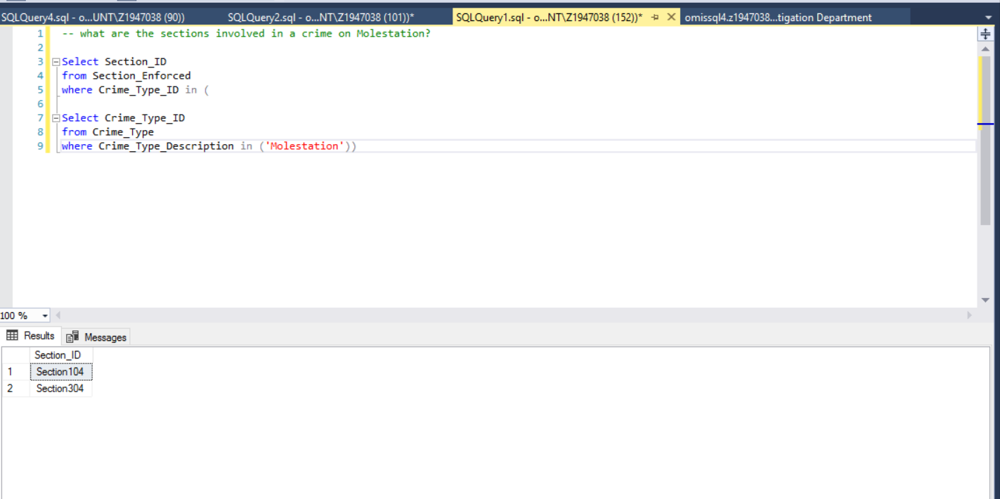

1. Mention all the police officers who work in Rajgir Police Station?

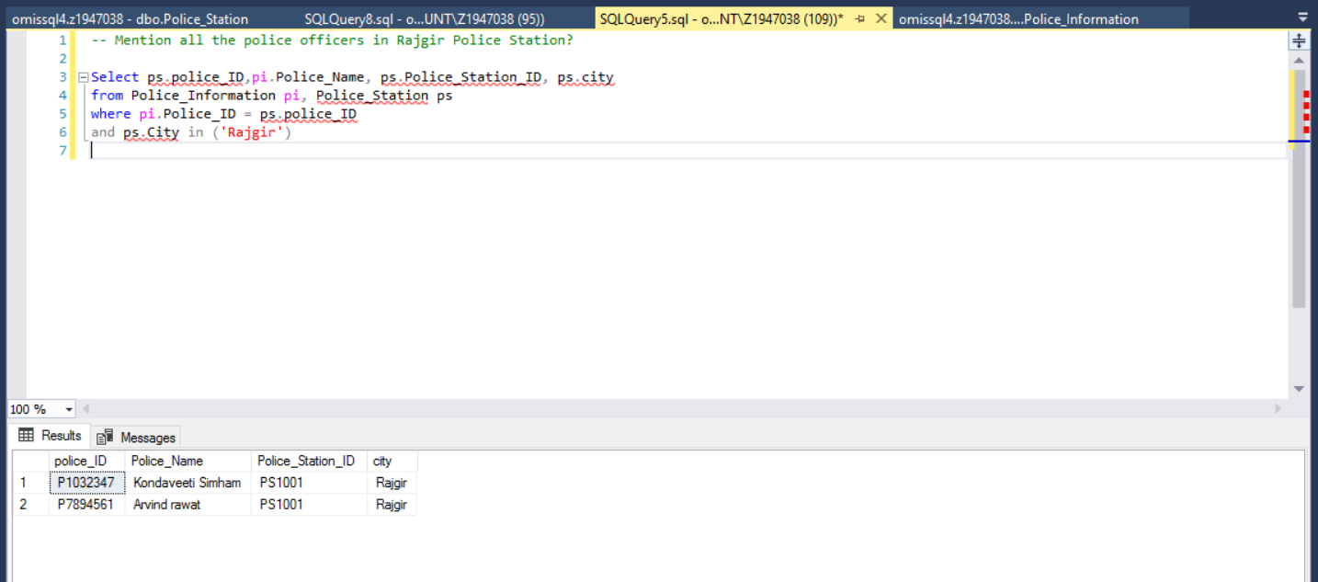

1. Find the Status of the victm “Deepika”?

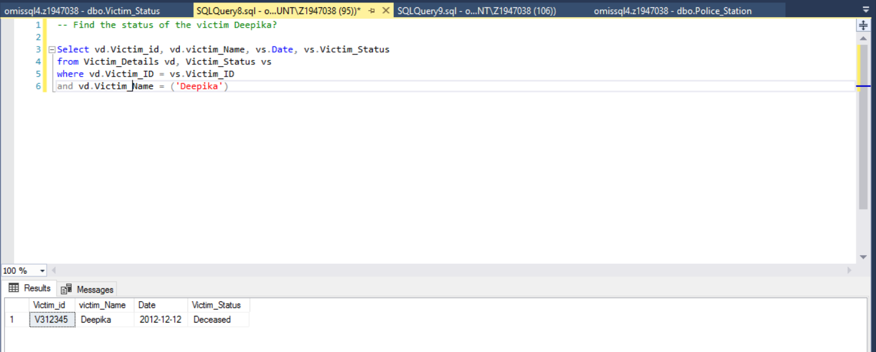

1. Dsiplay the Crime_ID, Suspects, and victims involved in the crimes that occurred on 2012/12/12?

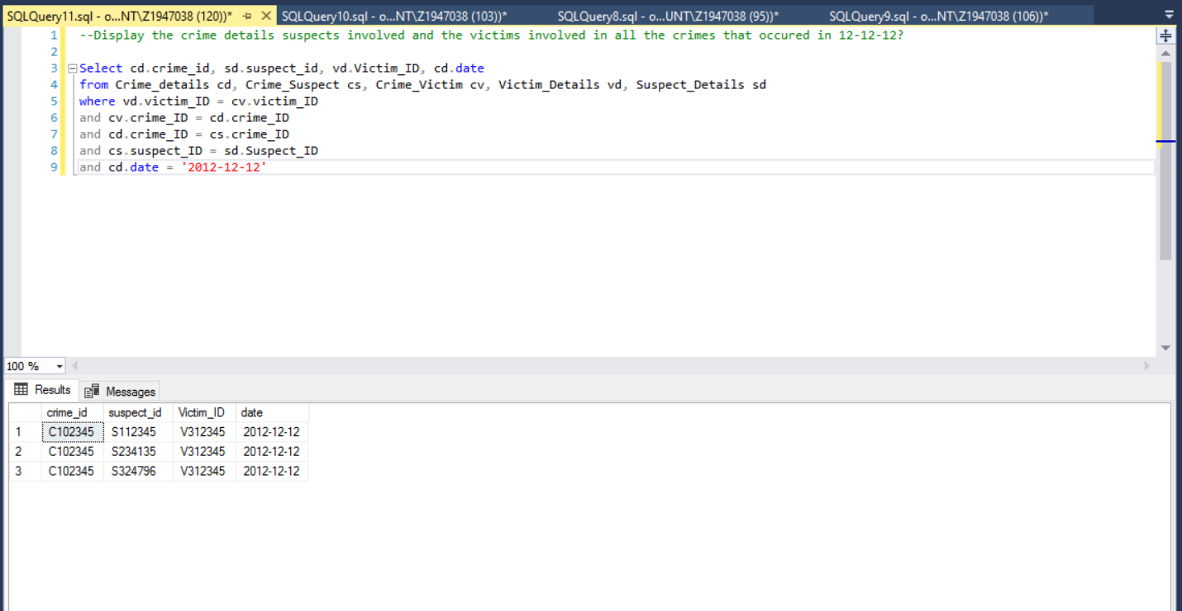

1. Write a query to display all the victims involved in the crime_id C836251?

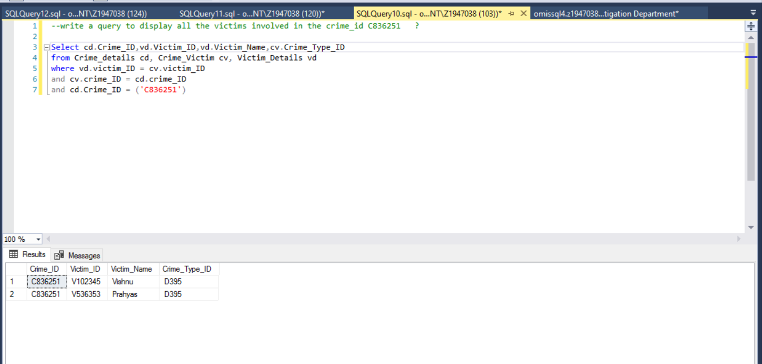

1. List all the crime investigations that are still in Pending?

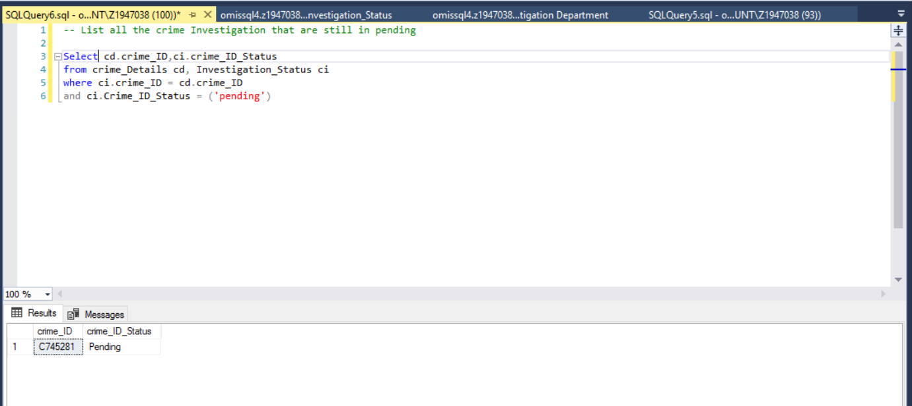

1. Find the crime and police_ID that informant “Srikanth” reported?

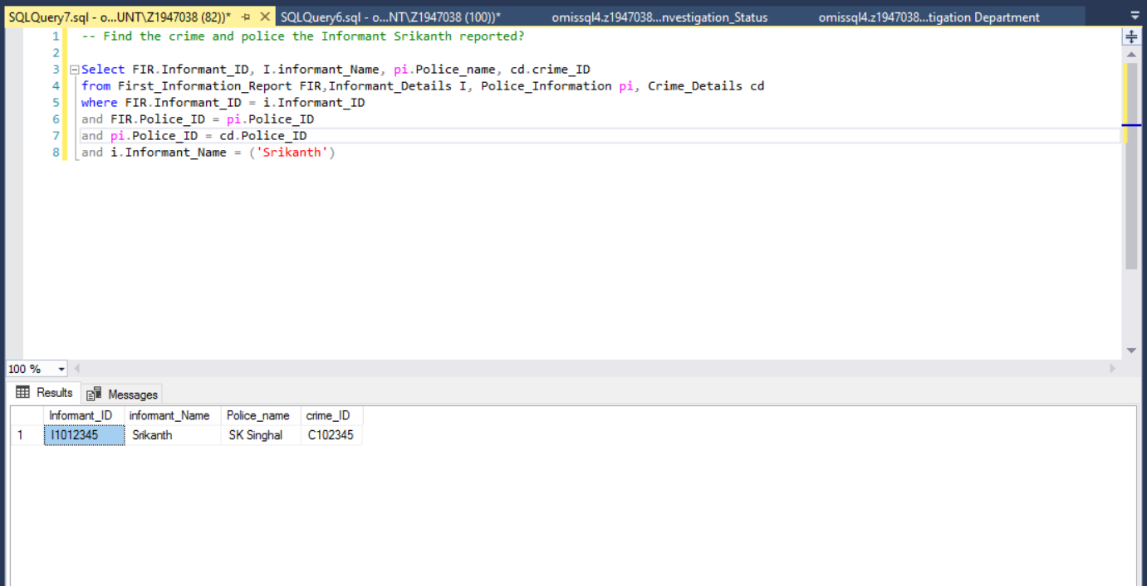

1. Find the names of the suspects who got Capital Punishment?

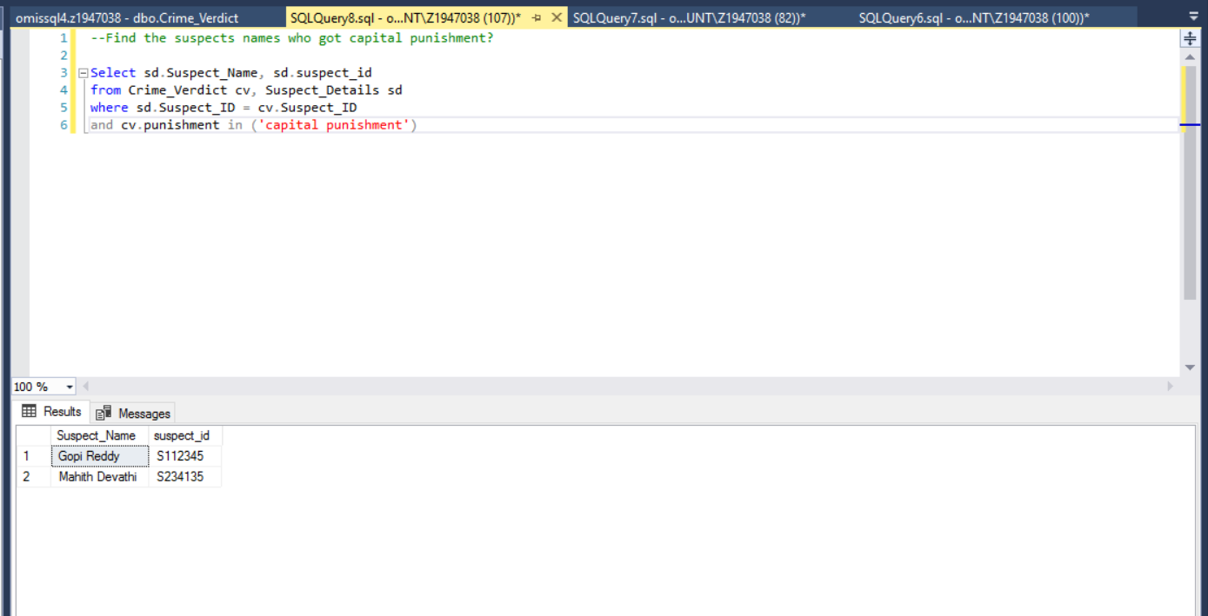

1. Find the Victims who are aged under 18 and are female?

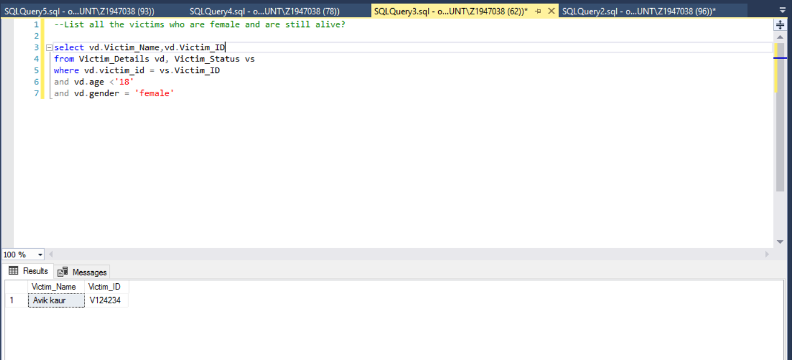

1. List the names of all the police officers whose police_ID starts with “P”?

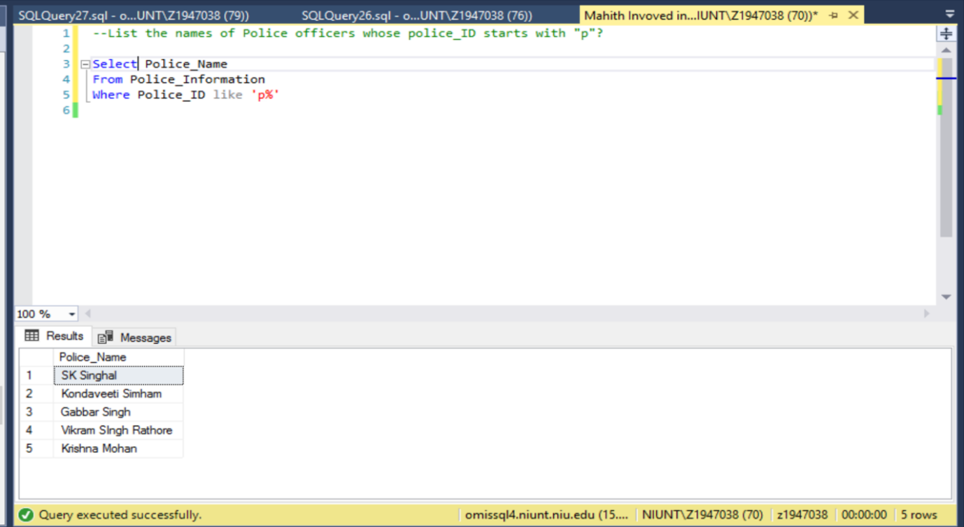

1. Find the Suspect names involved in the crime_ID C735213?

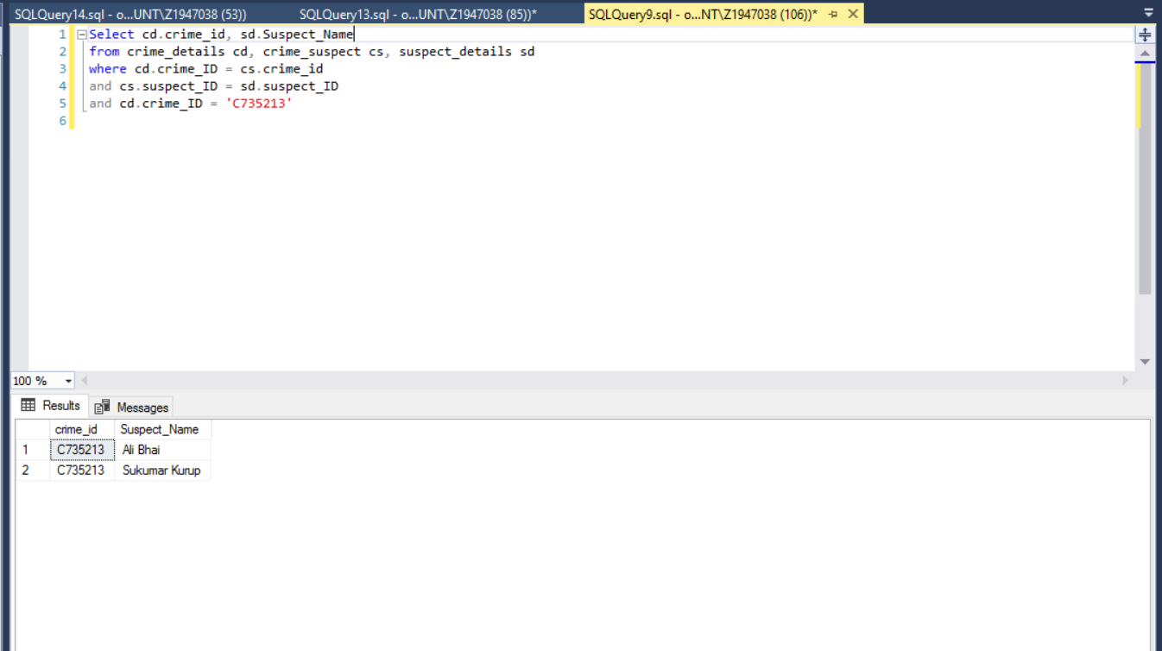

1. Display all the crime records and the police involved, display all the details in the crime table using right outer join?

